|  |
| --- |
|  |
| Microsoft Hyper-V  Setup and configuration |
| |  |  |  | | --- | --- | --- | |  |  | User manual | |

Table of content

1. Introduction 2

2. Requirements 2

3. Installing Hyper-V 2

a. Wake Server Manager 2

b. Add Roles and Features 2

c. Role-based or feature-based installation 3

d. Select Destination Server 3

e. Select Hyper-V server Role 4

f. Add Features 4

g. Click “Next” on the next two consecutive windows 5

h. Virtual Machine Migration 6

i. Default Stores 6

j. Confirm your installation selections 7

k. Reboot after done installing 8

## Introduction

Hyper-V is a Microsoft Product that is used to accomplish hardware virtualization. Virtualization as you know basically allows you to run several virtual machines (software computer) on the same hardware. These virtual machines behave exactly like a native/normal computer allowing you to install applications on top of an operating system.

Microsoft asserts that Hyper-V runs each virtual machine in its own isolated space, which means you can run more than one virtual machine on the same hardware at the same time.

## Requirements

Minimum hardware specifications to run Hyper-V

* A 64-bit processor with second-level address translation (SLAT). To install the Hyper-V virtualization components such as Windows hypervisor, the processor must have SLAT. ...
* VM Monitor Mode extensions.
* Enough memory - plan for at least 4 GB of RAM. ...
* Virtualization support turned on in the BIOS or UEFI:

Additionally, we will follow this documentation:

* [Install and Configure Hyper-V on Windows Server 2019 ...](https://computingforgeeks.com/install-and-configure-hyper-v-on-windows-server/)

to properly implement the service to our architecture

## Installing Hyper-V

### Wake Server Manager

Hit your Windows keyboard key and search for “Server Manager” and fire it up.

### Add Roles and Features

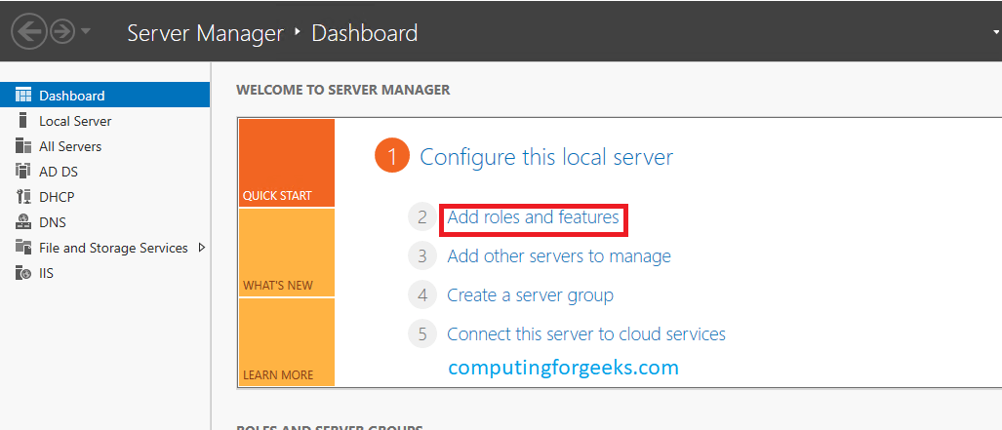Once your Server Manager is breathing nicely click on “Add Roles and Features” and click on “Next” on the first Window/Wizard that shows up as illustrated.

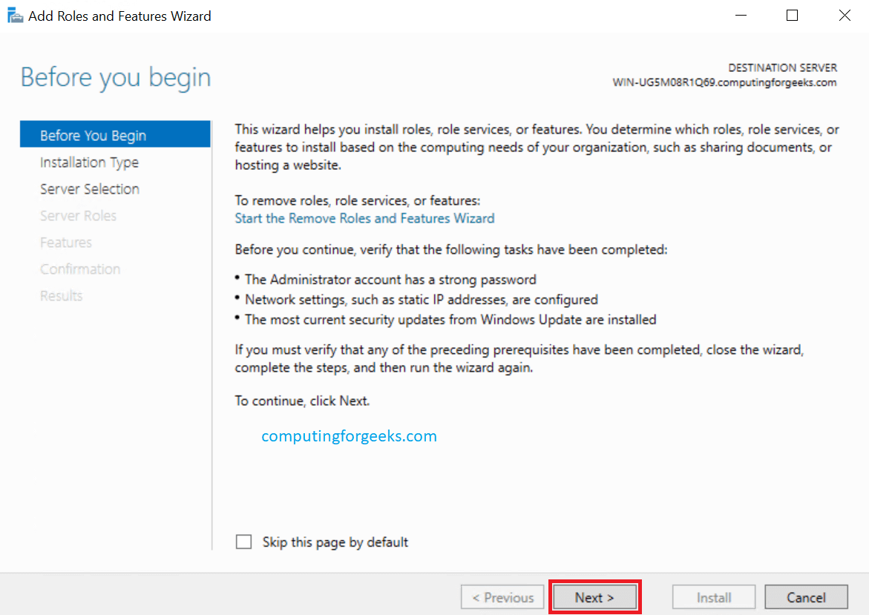

### Role-based or feature-based installation

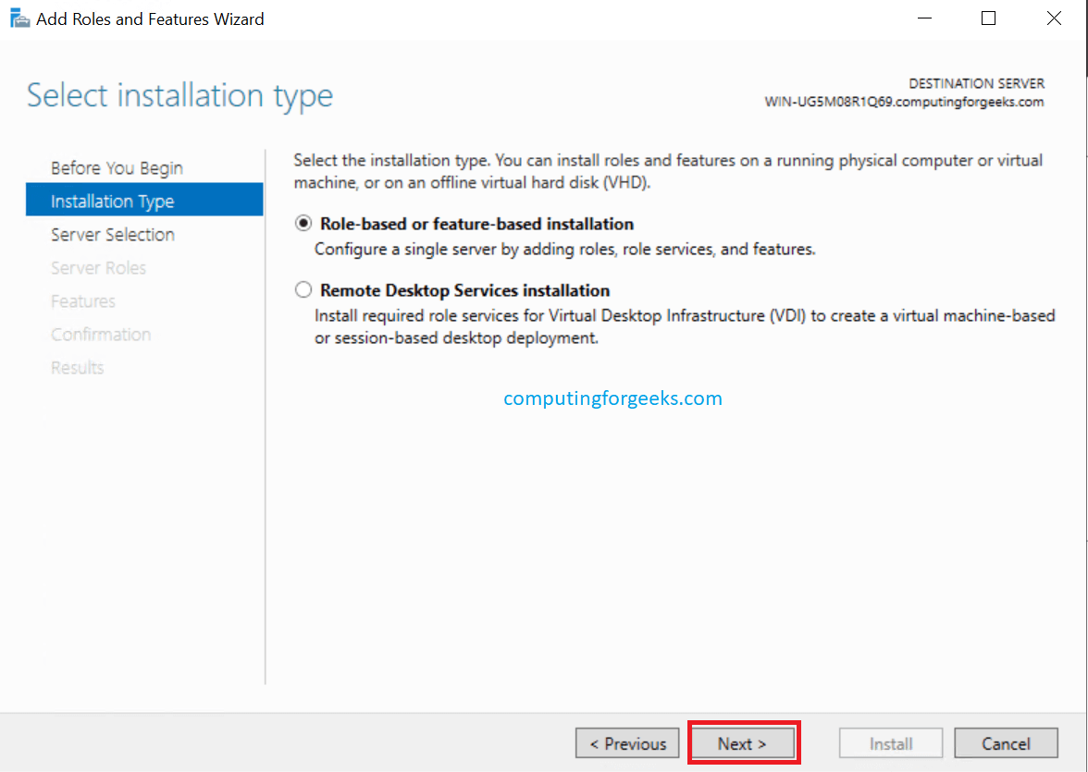On the next Window for “Select installation type“, choose Role-based or feature-based installation radio button and gladly hit “Next“.

### Select Destination Server

Choose the server you would wish to install Hyper-V on this window. Hit “Next” after that.

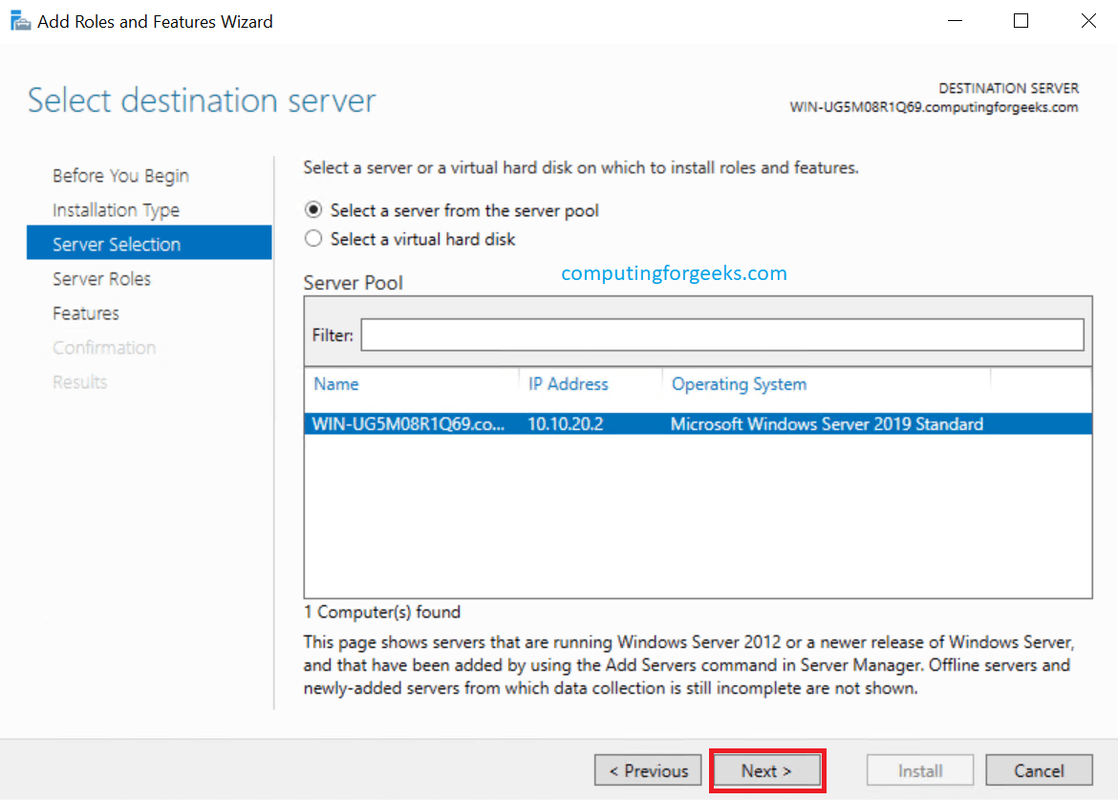

### Select Hyper-V server Role

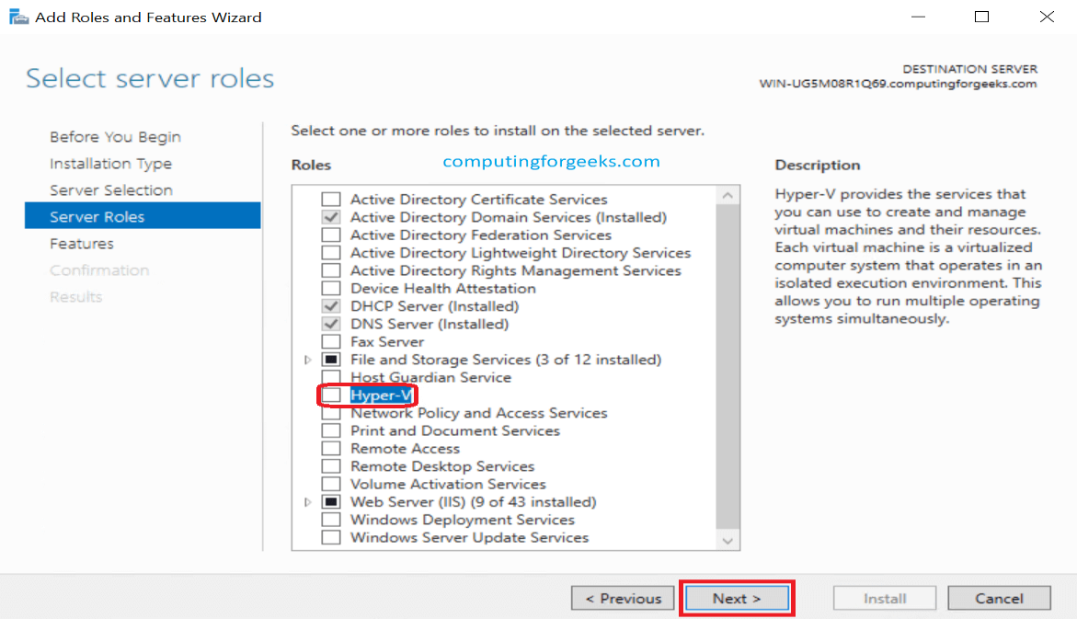The window that follows after step 4 gives you a list of many roles you can add to your server. Since we are in need of Hyper-V, go ahead and choose “Hyper-V” box. Click “Next” after you are done.

### Add Features

Clicking on Next on Step 5 will bring up a small pop-up window. On it, simply click on “Add Features” tab and click “Next” when done.

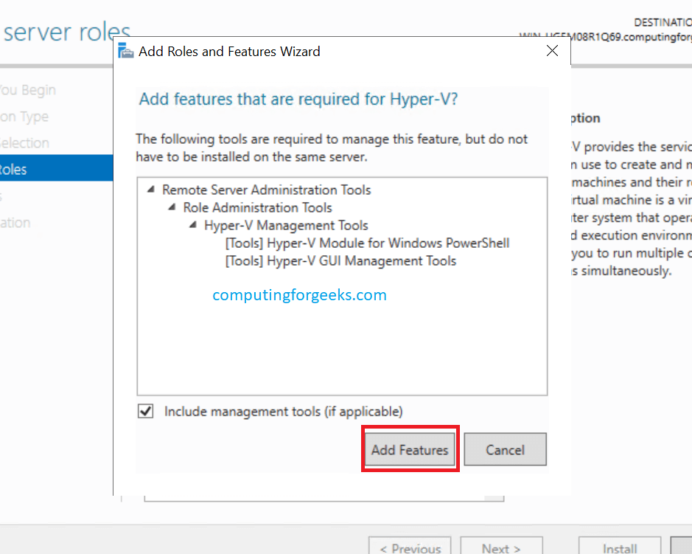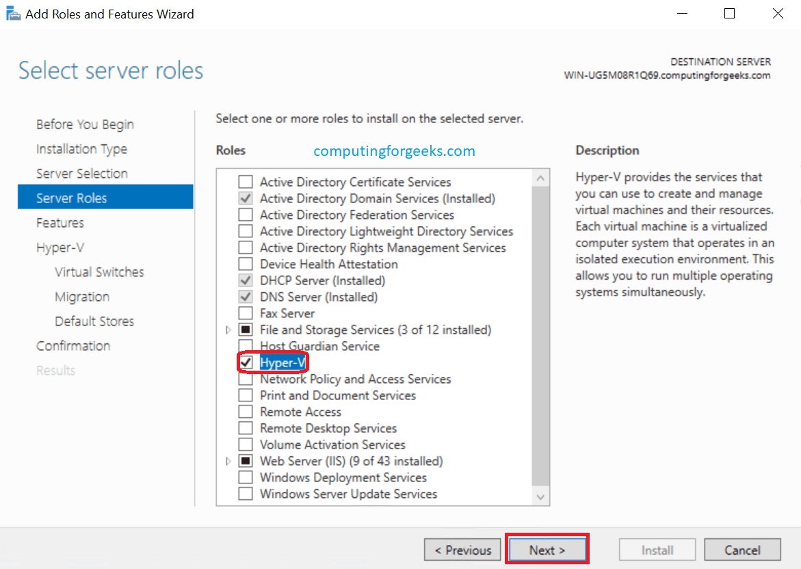

### Click “Next” on the next two consecutive windows

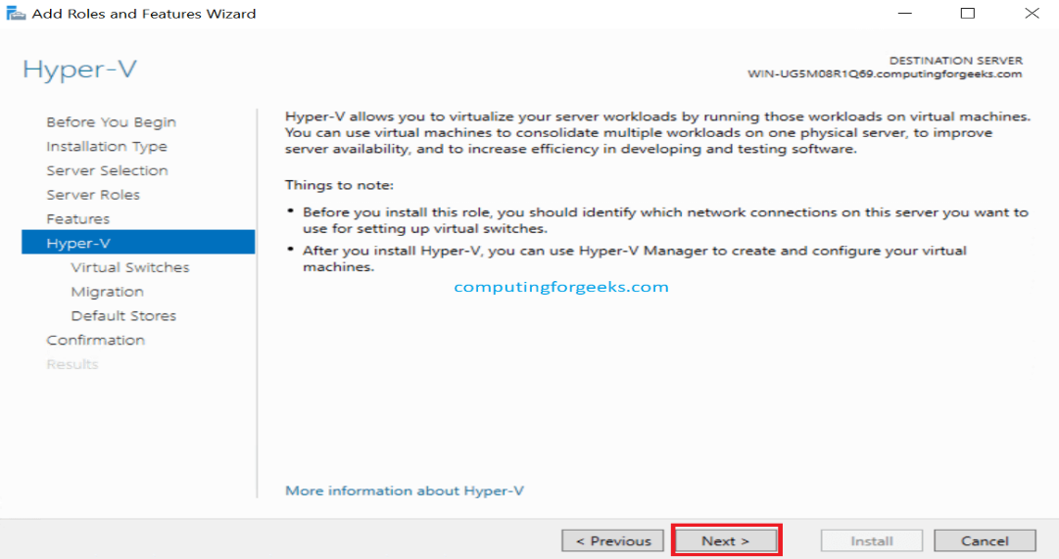

### Virtual Machine Migration

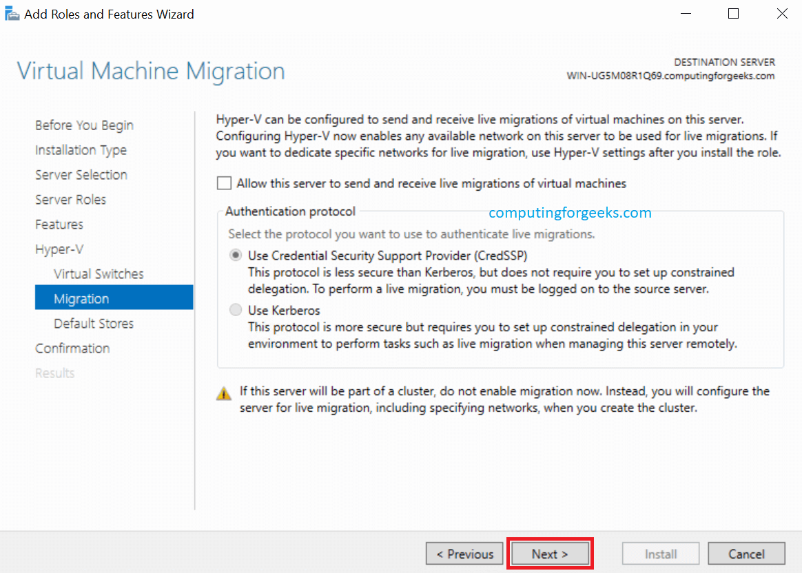The configuration of this step depends on whether you have a cluster or not. We are going to leave the defaults in this step since it is a standalone host. Click on “Next“

### Default Stores

In this step, we are going to specify where Hyper-V stores virtual hard disk files and virtual machine configuration files. You can specify the locations or partitions at your pleasure. Click “Next” after you are done.

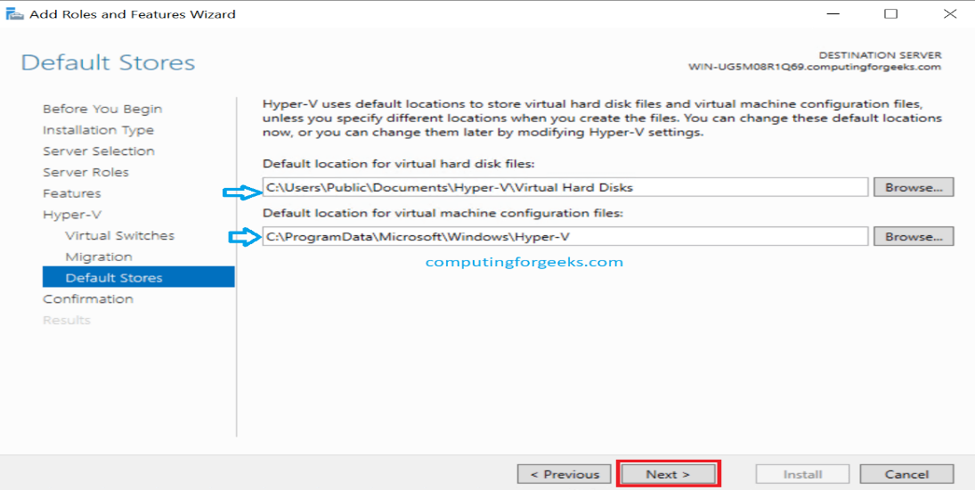

### Confirm your installation selections

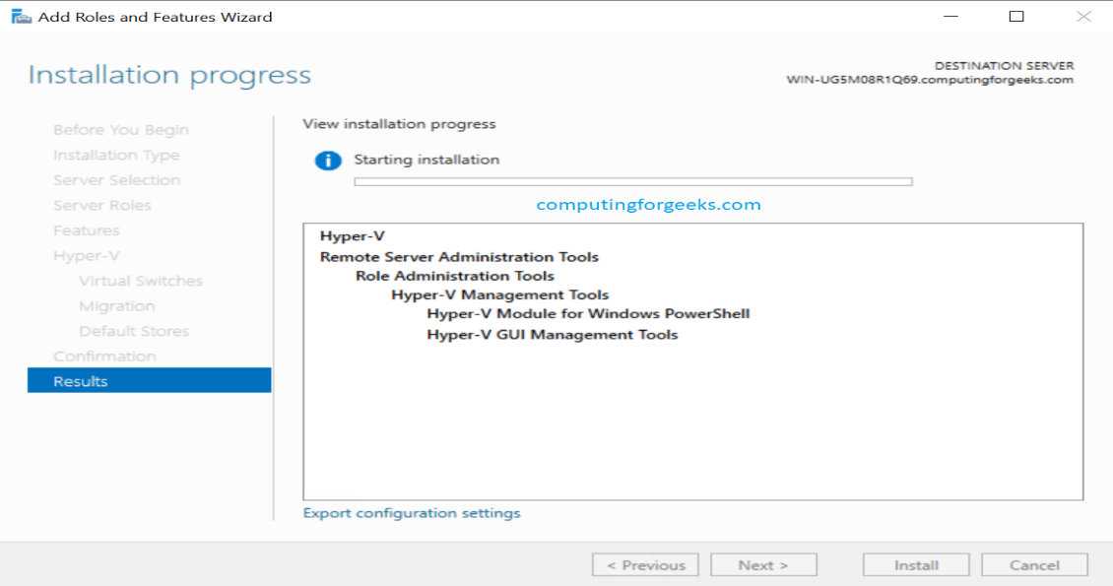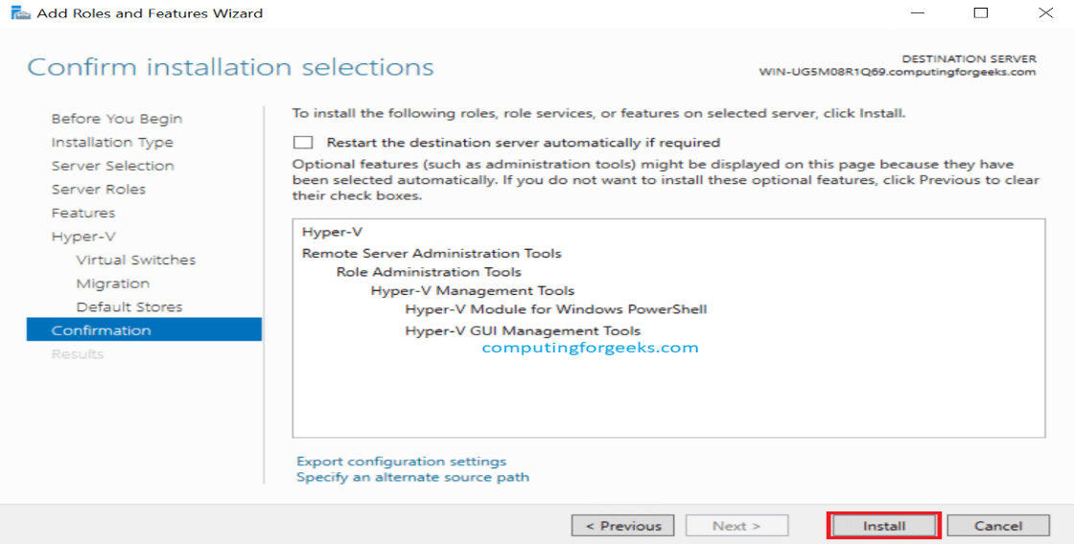Confirm if everything you would wish to be installed appears on the list that appears on this window. If all is okay, click “Install“.

### Reboot after done installing

Once your installation is complete, click on “Close” and then reboot/restart your server. And we are done!

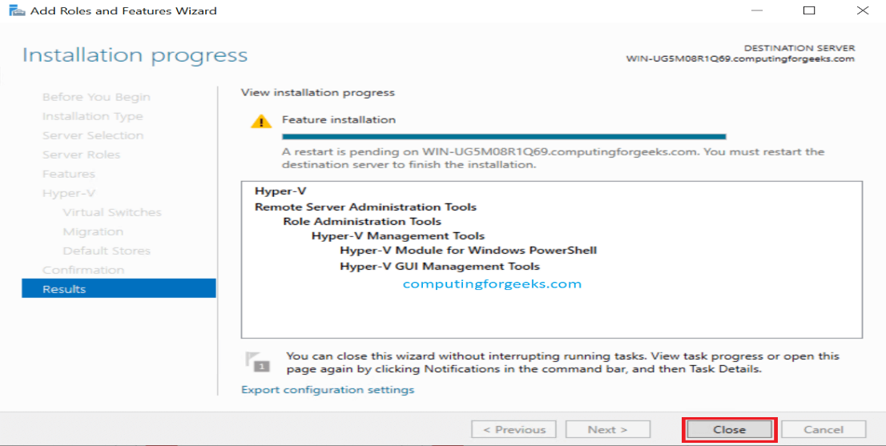

Now you are able to create virtual machines, virtual network switches and many more services.